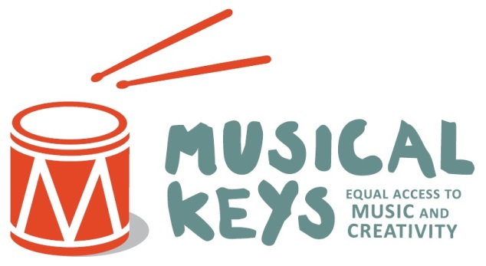

Volunteer sign-up form

Personal details
Name
Address
Telephone/mobile
Email address
Date of Birth
Do you hold a current DBS certificate for which you subscribe to the update service? | Yes No
Do you have access to a vehicle and are willing to travel? | Yes No

Further information
What area of Musical Keys are you interested in volunteering in (eg early years/with adults/event organisation/family support etc)
Do you have experience of working with vulnerable adults and/or children or any relevant training? If yes, please tell us here
Why do you want to volunteer for Musical Keys?
Please state your current availability (please circle the times that you ARE currently available) | Monday Tuesday Wednesday Thursday Friday Saturday Sunday  Am Pm Am Pm Am Pm Am Pm Am Pm Am Pm Am pm
When are you able to start volunteering?

Please complete this form and return via the options below – upon receipt we will send you out a comprehensive volunteer pack & Equal Opportunities and Monitoring form and will be in touch to make initial contact.

